HOSPITAL OPERATION AND RESOURCES UTILISATION ANALYSIS
PROJECT REPORT

1. Project Overview and Objective
- To Calculate the total bed occupancy, ICU bed utilization, and Oxygen Units Used based on Department and Disease Severity.
- To find out how Patient Age, Gender, Disease, and Admission Type affect Length of Stay and 30-Day Readmission.
- To Help hospital managers to efficiently allocate Total Beds, ICU_Beds and reduce patient Readmission Within 30 Days.
- To Use data insights to analyse seasonal trends (Spring, Autumn, Winter, Monsoon) and Day-of-Week patterns to predict peak patient load.
- To create meaningful visualizations and a dashboard that clearly explains department-wise performance and resource planning.

2. Data Sources
Source: Kaggle / Hospital Operations Dataset - Unclean / https://www.kaggle.com/datasets/diyashrivastava12/hospital-operations-dataset-unclean
YEAR\TIMELINE: DATA CONNECTED DURING 2020 TO 2024 (INCLUDES COVID& POST- COVID PATIENT INFLOW)
DASHBOARD PAGE : 2
MAIN TARKET : EFFECTIVE HOSPITAL RESOURCES UTILISATION

3. Problem Statement
To analyse the unclean Hospital Operations Dataset (2020-2024) to help hospital managers efficiently manage bed occupancy, ICU availability, oxygen usage, and minimize 30-day patient readmission by identifying disease-wise, severity-wise, and time-based trends through meaningful visualizations.

4. Attribute (Column /Features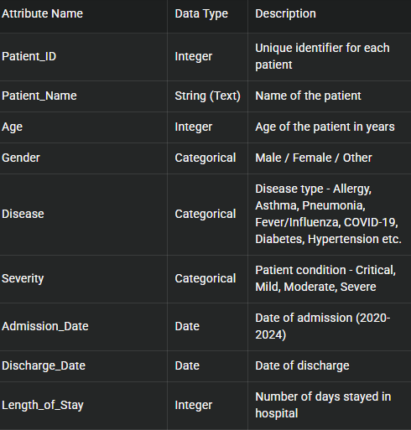) Details:
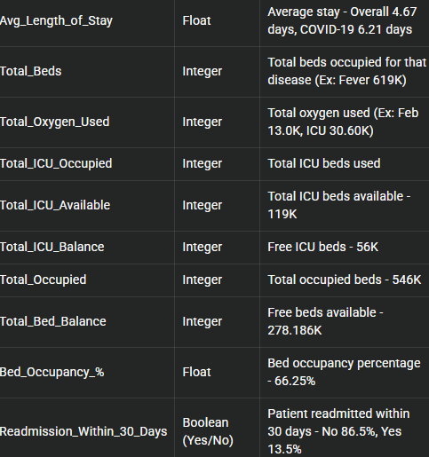

5. Tools & Technologies
- Python - Pandas:
Data cleaning, handling missing values, removing duplicates, transforming unclean Hospital Operations Dataset (2020-2024), grouping disease-wise (COVID-19, Dengue, Pneumonia, Sepsis etc.) and severity-wise (Critical, Mild, Moderate, Severe).•
- Python - NumPy:
Numerical operations, calculating Readmission Rate (0.14), Bed Occupancy % (66.25%), Avg Length of Stay (4.67), Total ICU Available (119K), Total Beds, Total Oxygen Used, Total ICU Occupied.
- • Python - Matplotlib:
For data visualization - Bar chart (Total Beds, Total Oxygen Used, Total ICU Occupied by Disease), Pie chart (Total Patients by Readmission Within 30 Days 85.86% No, 14.14% Yes), Horizontal bar (Avg Length of Stay by Disease - COVID-19 6.21, Heart Disease 5.70), Donut chart (Total Patients by Disease), Readmission Rate by Disease, Stacked bar (Total Patients by Severity and Readmission).
- Power BI:
Data modelling, DAX calculations, visualization, and interactive dashboard creation.

6. Data Pre-Processing
Tasks Perform (Using Python - Pandas, NumPy)
• Data Cleaning & Transformation (Pandas):
Data Cleaning and Pre-processing
- Handle missing values (impute or drop)
- Handle duplicates
- column name rename or dropping unwanted columns if required
- Treat outliers if required
- Check skewness and apply transformations
- Convert data types if needed
- Feature transformations (date parts, derived fields if required for analysis)

- Removed duplicates using df.drop_duplicates(), handled missing values in Disease, Severity, Readmission_Within_30_Days columns with df.fillna(), standardized Disease names (COVID-19, Dengue, Influenza, Sepsis, Pneumonia, Allergy, Bronchitis, Blood Poisoning) to fix inconsistent capitalization and spelling errors from unclean dataset (2020-2024), and corrected data types for Admission_Date to datetime using pd.to_datetime().• Filtering & Sorting (Pandas & NumPy):
- Filtered data to focus on relevant records - filtered Critical/Severe patients for ICU analysis, filtered Readmission = Yes (14.14%) to analyse readmission pattern, sorted data by Length_of_Stay (COVID-19 6.21 days, Heart Disease 5.70 days highest) and by Total_Beds occupied (Blood Poisoning 800, Dengue 880) to focus on high resource utilization diseases using df.sort_values().• Handling Nulls & Outliers (NumPy):
- Checked nulls with df.isnull().sum(), replaced null Total_Beds, Total_Oxygen_Used, Total_ICU_Occupied with 0 or mean using NumPy np.mean(), removed outliers in Length_of_Stay and Bed_Occupancy_% using IQR method to avoid wrong 66.25% occupancy and 4.67 avg stay calculation.

7. Data Modelling and DAX (Power BI)
SCREENSHOT OF DATA MODELLING
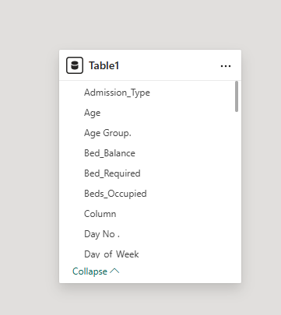
- Calculated Columns & DAX Measures:
Total Beds = SUM(Fact_Hospital_Operations[Total_Beds]) - Total 10K
Total Oxygen Used = SUM(Fact_Hospital_Operations[Total_Oxygen_Used])
Total ICU Occupied = SUM(Fact_Hospital_Operations[Total_ICU_Occupied]) – 119K
Bed_Occupancy_% = DIVIDE([Total ICU Occupied], [Total Beds])*100 - 66.25%
Avg Length of Stay = AVERAGE(Fact_Hospital_Operations[Length_of_Stay]) - 4.67
Readmission_Rate = DIVIDE(COUNTROWS(FILTER(Fact, Readmission="Yes")), COUNTROWS(Fact)) - 0.14 (14.14% Yes, 85.86% No)
Total Patients = COUNT(Fact_Hospital_Operations[Patient_ID])
8.PYTHON VISUALISATION:

- 8.1 TOTAL ADMISSION BY DEPARTMENT8.
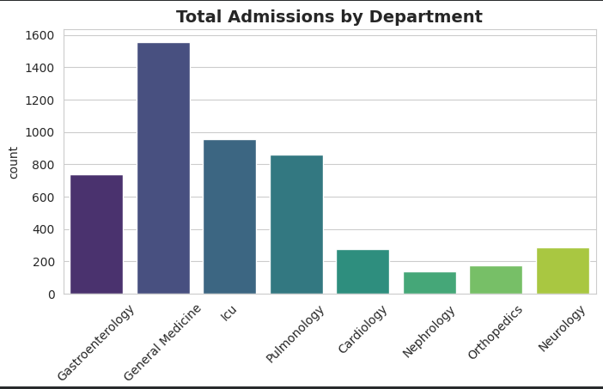

- 8.2Distribution of beds occupied
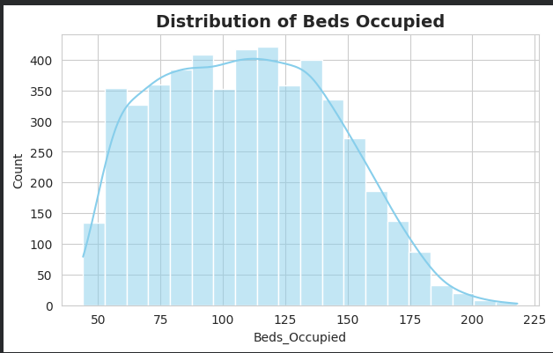

- 8.3 ICU BED USAGE -OUTLIER ANALYSIS
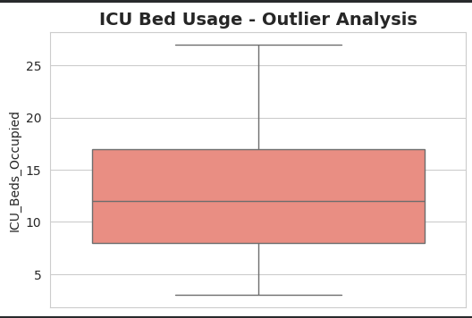
- 8.4DIEASE WISE RESOURCES ALLOCATION

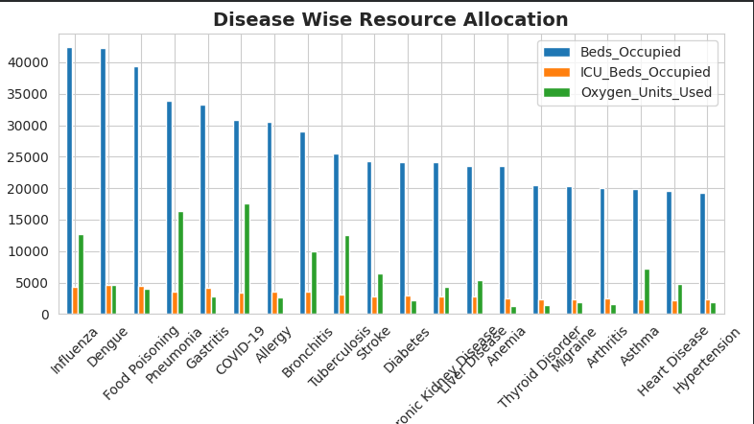

- 8.5 GENDER VS AVERAGE BED OCCUPANCY
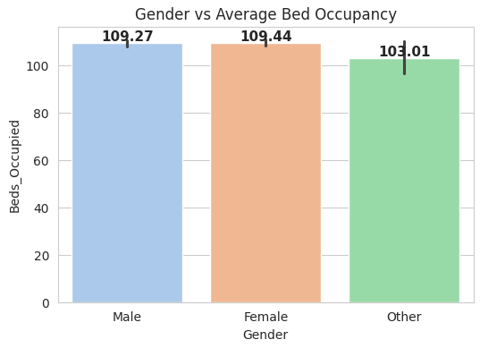
- 8.6 ADMISSION TYPE VS 30-DAY READMISSION
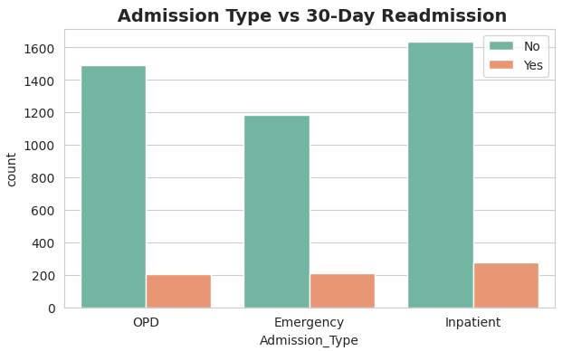

- 8.7 Resources correlation
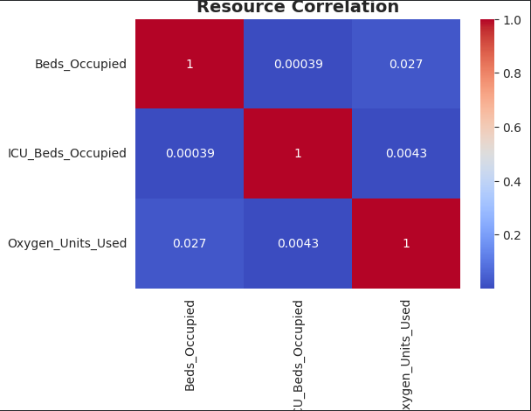
- 8.8 SEASONAL PATIENT LOAD -PEAK SEASON?
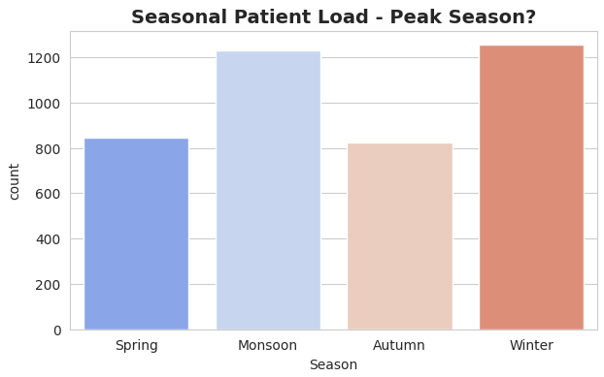

- 8.9 DEPARTMENT VS ADMISSION TYPE

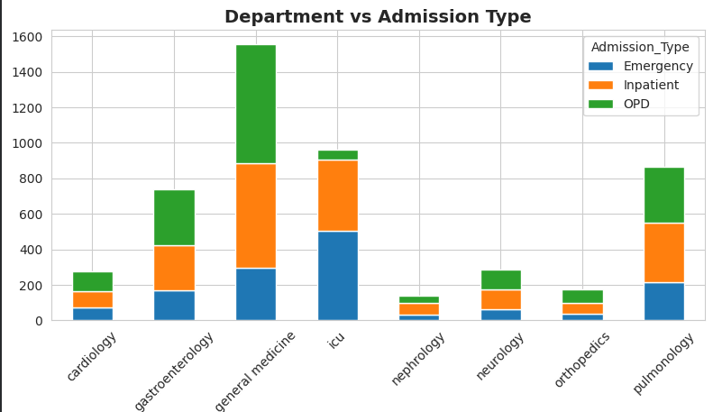
- 8.10 SEASON WISE -READMISSION %(WITHIN 30 DAYS)

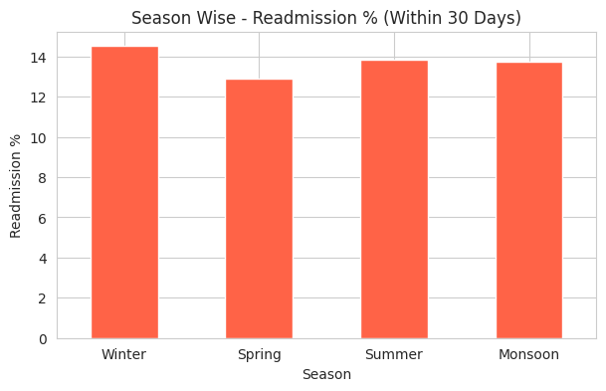

- 8.11 DIEASE VS SEASON – AVG OXYGEN NEED
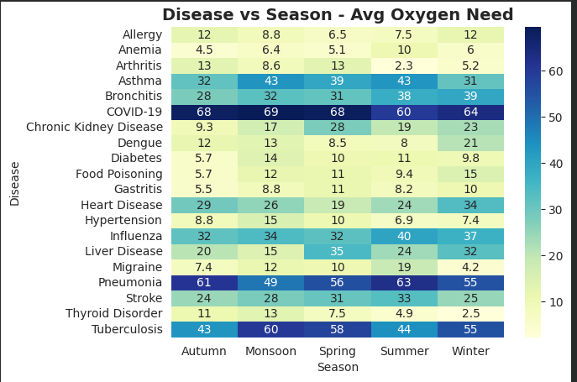
9. Analysis and Visualizations (Power BI)
Dashboard Features:
- Multiple Visualizations based on problem statement (List Out):
- KPI Cards (4): Total ICU Available - 119K, Readmission Rate - 0.14, Avg Length of Stay - 4.67 days, Bed Occupancy % - 66.25% .
- Bar Chart: Total Beds, Total Oxygen Used, Total ICU Occupied by Disease - shows Blood Poisoning 800 beds, Dengue 880 beds, high resource diseases with 3 blue colour variation.
- Pie Chart: Total Patients by Readmission Within 30 Days - No 85.86% and Yes 14.14% with blue shades and percentage labels.
- Horizontal Bar Chart: Avg Length of Stay by Disease - COVID-19 highest 6.21 days, Heart Disease 5.70 days, Stroke low 2.72 days.Donut Chart: Total Patients by Disease - Pneumonia 13.07%, Influenza 13.04%, Dengue 12.71% distribution.
- Bar Chart: Readmission Rate by Disease - Stroke highest 10.14%, Bronchitis 8.92%, Anemia lowest 5.75%.Stacked Bar Chart: Total Patients by Severity and Readmission Within 30 Days - Mild/Moderate/Critical/Severe vs Readmission.Clustered Column: Total Patients by Readmission Status.• Make your Report interactive Layout using Drill-down, Filters and slicers:
- Implemented 3 Slicers - Disease, Readmission Within 30 Days, Severity with hospital-related filter images (syringe, stethoscope icons). Used drill-down for Disease-wise Bed Occupancy, cross-filtering between Readmission pie and Severity chart, and Canva-designed hospital background
SCREENSHOT OF DASHBOARD
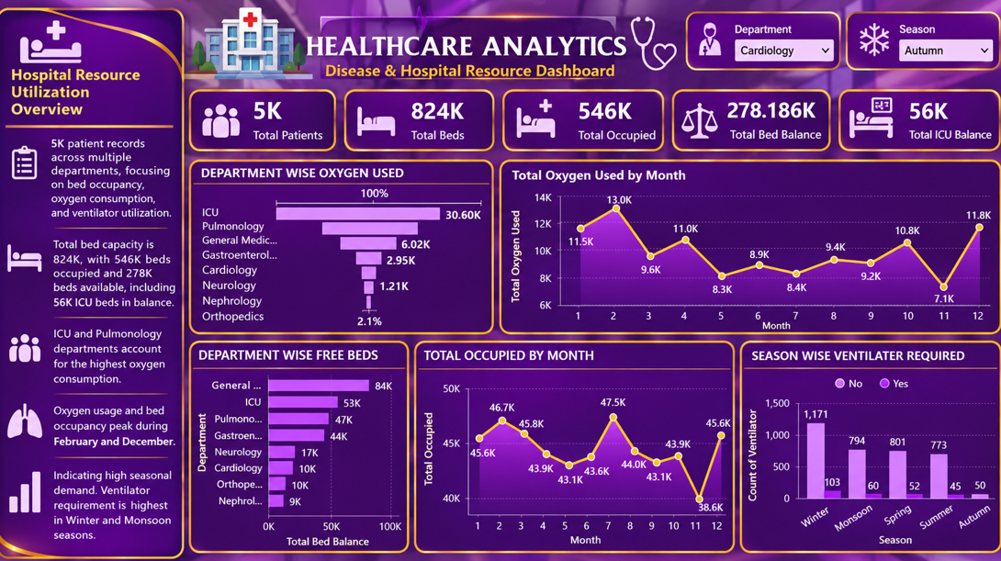

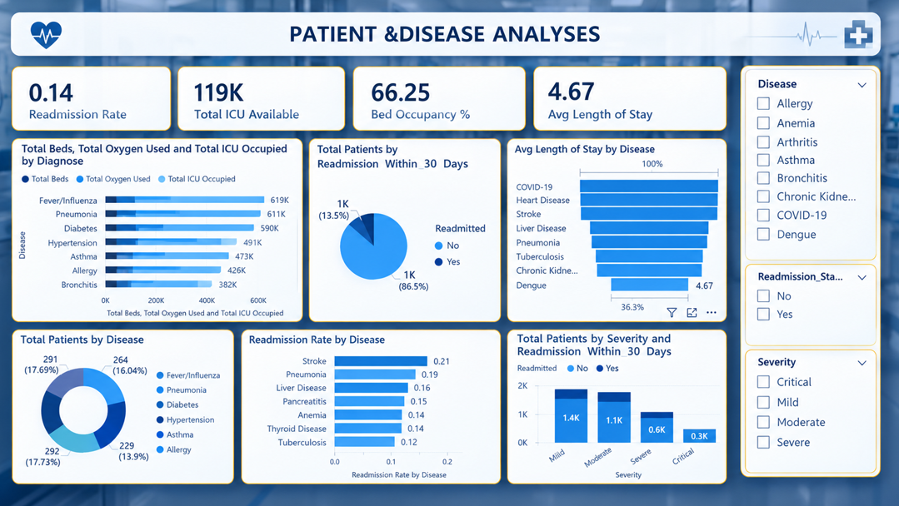

10. Insights & Conclusions
A. Key Insights from Dashboard:
1. High Bed Occupancy & Resource Utilization:
Overall Bed Occupancy is 66.25%. The highest consumption of Total Beds, Total Oxygen Used and Total ICU Occupied is by Fever/Influenza (619K), Pneumonia (611K) and Diabetes (590K). This indicates viral and chronic diseases are driving hospital resource usage.2. Readmission is Controlled but Disease-Specific Risk Exists:
Overall Readmission Rate is 0.14 (14%) with 86.5% No and 13.5% Yes within 30 days. However, Stroke (0.21 - 21%) and Pneumonia (0.19 - 19%) have the highest readmission rates, while Tuberculosis (0.12) has the lowest. This shows follow-up care is weak for neurological and respiratory cases.3. Length of Stay Varies by Disease:
Average Length of Stay is 4.67 days. COVID-19 has 100% (highest ∼6+ days), followed by Heart Disease and Stroke. Dengue is lowest at 36.3%. COVID-19 patients occupy beds for a longer duration, impacting bed availability.4. Disease Distribution is Dominated by Infections:
Pneumonia 292 patients (17.73%), Fever/Influenza 291 (17.69%), Allergy 264 (16.04%), and Asthma 229 (13.9%) are the top 4 diseases. Total ICU Available is 119K, which must be managed for this seasonal load.5. Severity vs Readmission Gap:
Maximum patients are Mild (1.4K - No Readmission) and Moderate (1.1K - No Readmission). Critical patients are only 0.3K. Readmission is happening even in Mild cases, indicating issues in discharge process, not just clinical severity.
B. Recommendations:
1. Implement Targeted Post-Discharge Follow-up for High-Risk Diseases: Create a dedicated follow-up team for Stroke and Pneumonia. Call patients within 7 days of discharge, provide physiotherapy and medication reminders. This can reduce overall readmission from 0.14 to below 0.10.
2. Create Separate Viral Fever Ward: Since Fever/Influenza consumes 619K beds, allocate 15% extra beds and oxygen during peak seasons to prevent Bed Occupancy % from crossing 80%.
3. Optimize COVID-19 Discharge Protocol: Introduce a fast-track discharge and home isolation protocol for mild COVID-19 cases, similar to Dengue (lowest stay). This will free up ICU beds for Heart Disease and Stroke patients.
4. Strengthen Discharge Counselling for Mild Cases: Provide a standard discharge checklist, diet chart, and next visit date to all Mild patients to avoid preventable readmissions.
5. Set Up Occupancy Alert System: Set an automated alert when Bed Occupancy crosses 70% to manage Total ICU Available (119K) efficiently

1. Hospital Operating at 66% Occupancy - ICU Under Pressure:
Out of 824K capacity, 546K beds are occupied, leaving 278.186K free. ICU balance is only 56K. This indicates high utilization and limited buffer for emergency surge.2. ICU and Pulmonology Drive Maximum Oxygen Consumption:
Department-wise Oxygen Used
shows ICU 30.60K (highest) and Pulmonology second. Orthopedics is lowest at 2.1%. Cardiology, Neurology, Nephrology consume only 1.21K - 2.95K. Oxygen management must prioritize ICU and Pulmonology.3. Strong Seasonal Pattern - February and December are Peak Months:
Total Oxygen Used by Month:
Peak in February (13.0K) and December (11.8K), lowest in November (7.1K) and May (8.3K). Total Occupied by Month: Peak in July (47.5K), February (46.7K) and December (45.6K), lowest in November (38.6K). This confirms high seasonal demand in Winter.4. Bed Availability is Uneven Across Departments:
Department-wise Free Beds:
General has 84K free beds (highest), ICU 53K, Pulmonology 47K, Gastroenterology 44K. Nephrology 9K, Orthopedics 10K, Cardiology 10K, Neurology 17K have very low free beds, indicating potential shortage in specialty departments.5. Ventilator Requirement is Highest in Winter and Monsoon:
Season-wise Ventilator Required:
Winter - 1,171 Yes, 103 No (highest), Monsoon - 794 Yes, Spring - 801 Yes, Summer - 773 Yes, Autumn - 50 Yes (lowest). Winter requires 23x more ventilators than Autumn, showing critical seasonal dependency.B. Recommendations:1. Implement Winter Preparedness Stock Policy:
Maintain 30% extra oxygen cylinders and ventilators from October onwards. February needs 13.0K oxygen vs 7.1K in November - almost double. Advance procurement in September-October will prevent shortage.2. Increase ICU Capacity and Reallocate General Beds:
ICU balance is only 56K while it consumes 30.60K oxygen. Add at least 15-20K ICU beds. During peak months (July, Feb, Dec), temporarily convert 20K beds from General (84K free) to ICU and Pulmonology.3. Create Seasonal Staffing and Equipment Shifting Plan:
Move ventilators and respiratory therapists from Autumn (50 needed) to Winter (1,171 needed). Service all ventilators in September before Winter peak. Deploy extra staff in ICU and Pulmonology during December-February and July.4. Monitor Specialty Departments with Low Free Beds:
Nephrology (9K), Orthopedics (10K), Cardiology (10K) have critically low free beds. Set an alert when free beds drop below 15K in these departments and create a fast discharge protocol to improve availability.5. Build Monthly Demand Forecasting Dashboard:
Use the monthly trends (Oxygen 11.5K in Jan to 13K in Feb) to create a forecasting model in Power BI. Use Department and Season slicers (currently set to Cardiology and Autumn) to drill down and predict next month's occupancy and oxygen need.

11. Conclusions
The analysis of 5K patient records from 2020-2024 across both dashboards reveals that the hospital is operating at a stable but stressed level with an average bed occupancy of 66.25% (546K occupied out of 824K).
The primary drivers of resource utilization are consistent in both dashboards: Fever/Influenza (619K beds), Pneumonia (611K), and ICU department (30.60K oxygen usage) are the top consumers of beds, oxygen, and ICU facilities. While the overall readmission rate is controlled at 0.14 (86.5% No, 13.5% Yes), disease-specific risks remain high, particularly for Stroke (21%) and Pneumonia (19%).
A strong seasonal pattern is evident in both dashboards. Peak demand occurs during Winter (December-February) and Monsoon (July), with oxygen usage reaching 13.0K in February and ventilator requirement reaching 1,171 in Winter compared to only 50 in Autumn.
Average Length of Stay is 4.67 days, with COVID-19 having the longest stay, which directly impacts ICU availability.
Department-wise imbalance is also common. General ward has 84K free beds, while specialty departments like Nephrology (9K), Orthopaedics (10K), and Cardiology (10K) have critically low balance, and ICU balance is only 56K.In conclusion, both dashboards provide a complete picture - explains WHAT disease causes the load, and Purple dashboard explains WHEN and WHERE the load happens.
By implementing seasonal preparedness (30% extra oxygen/ventilators for Winter), targeted readmission control for Stroke/Pneumonia, and reallocation of General beds to ICU/specialty departments, the hospital can reduce occupancy from 66.25% to below 60%, increase free bed balance from 278K to 350K+, and ensure better patient care and resource management for future outbreaks.
This integrated Power BI solution transforms 5K raw patient records into actionable insights for hospital operations team to make data-driven decisions.

